Scoil Naomh Iósaf Baltinglass, Co. Wicklow

Principal

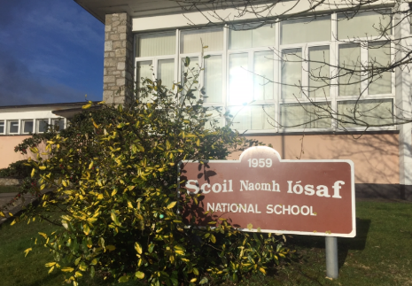
Principal: Dr. Mairead Hennessy
Deputy Principal: Ms. Carmel Doyle (M.Ed)
Email: principal@snibaltinglass.ie
Secretary: Ms. Rachel Fennell

March 19th 2020
Dear Parents,
The staff at Scoil Naomh Iosaf hope you and your children and families are keeping safe and well at this very difficult time. It is difficult for children when their normal routine is disrupted and many of them will miss the normality of coming to school each day, meeting friends and engaging with their work in class. In the midst of all of this, we hope there is a small silver lining in having the opportunity to spend quality time with close family. We know the children are keeping in contact with their friends and extended family through social media and phone calls. It’s good to keep in touch with each other.
It is a very surreal situation for us all. The staff are finding it upsetting not to be coming to school and preparing for teaching and learning on a daily basis. Unfortunately, in this unprecedented crisis there is no alternative. We hope the children are keeping well, taking the opportunity to engage with the work set by their teacher, continuing to read for pleasure and keeping active. We are aware that many parents may be worried that their children will fall behind with their school work. Please be assured that the teachers will work extremely hard and efficiently when the children return to ensure that that each child can reach their potential. In the meantime, learning from home is also very beneficial.
It is important to remember that learning at home and learning at school are both effective but operate in different ways. In school, the children engage in conversation based learning, partake in activities organised by the teacher, engage with learning on the interactive white board in addition to completing worksheets and their books. The school day is interspersed with written work, oral discussion, pair work, reading, group work and many more activities. Younger children in particular need a lot of teacher support with their learning and need lots of physical activity breaks.
Many of you are now finding yourselves plunged into home-schooling your children for the next few weeks. It is recommended that parents try not to replicate school at home - as I mentioned above, school is a different experience with children working in pairs and groups and activity based learning a lot of the time. However, learning at home is also very effective. It is a good idea to let children choose which learning activity they might like to do first, next etc. and to work with their parent to devise a workable timetable. If possible, it is a good idea to include time for reading, writing, maths, music, drawing and physical activity each day. Children can also work with their parents to learn vital life-skills: making meals, baking, cleaning up, making their bed and sorting their clothes, dusting, gardening etc. Structure the day around what works for the family. If your children like a walk in the morning or to play ball after breakfast, you can do that and then do maths and reading later in the morning! Rewards can be a great incentive and encourage children to get the work done and keep the enthusiasm going. Star/sticker charts, polo mints on a straw, pasta in a jar or raffle tickets are some ideas for keeping track of rewards. These rewards don’t have to be expensive or edible! Screen-time, a movie of their choice, hot chocolate and marshmallows, a lie-in, staying up late, playing a game with a parent or whatever it is that your children place value on will work as a reward.
We are aware that some of the children are very eager and enthusiastic and have already been working away on their homework packs. In the coming weeks, the teachers will organise further suggestions for work the children can engage with. Many of the older children have been assigned projects that involve research, sketching, and presenting information on their topic and these projects will involve significant work and time! In the event that parents/pupils would like more work I have included a number of useful suggestions below.
Health is wealth and I hope that all our children and families stay safe and well. I will keep you all up to date with any relevant information and recommendations from the Department of Education as soon as it is issued.
We are aware that many parents are working from home, cooking meals for families and ensuring their children and extended family are cared for. Do your best to ensure each child spends some time on their learning and school work each weekday. Having a routine will help your children to cope at this difficult time. Many people have other more important worries and we are aware of that also. Health, happiness and well-being are so important. Everyone is doing their best and your best is just great.
Further information and activities will be added to our school website www.snibaltinglass.ie over the coming weeks.
We are looking forward to seeing all our pupils again as soon as possible and in the meantime we hope you all keep safe and well.

Kindest regards,

Mairead Hennessy.

Suggestions for Additional Learning and Activities for Children in SNI

- Twinkl Resources
Twinkl Ireland are offering a free subscription for Parents following the school closures and have kindly organised a wide variety of learning activities for all class levels. Twinkl is an invaluable resource and is widely used by schools and teachers across Ireland to enhance teaching and learning. You can download a school closure pack for each class from junior infants to sixth class along with any other resources on the site. It would be a great idea to set up a free account while the offer is still available and download any activities and worksheets you feel would benefit your child over the coming weeks. There are four closure packs available – enough work for four weeks.
Step 1: Go to www.twinkl.ie/offer
Step 2: Enter your email address and create a password.
Step 3: Enter the Offer Code
IRLTWINKLHELPS

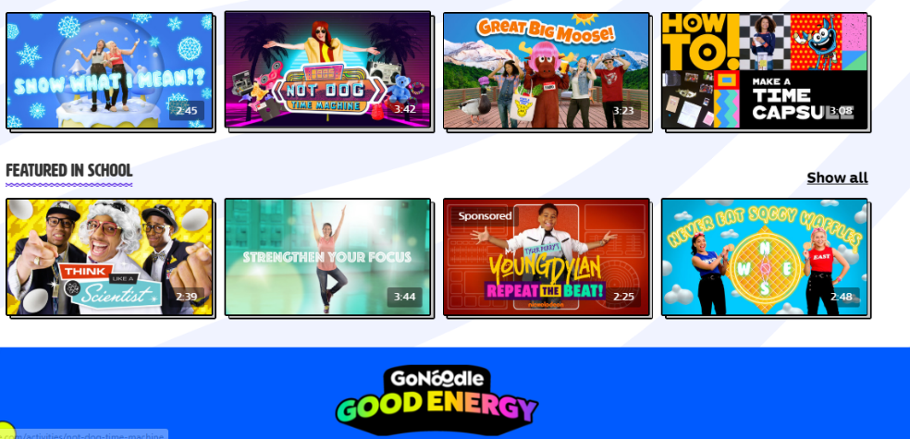
- Be Active! Try Go Noodle!
It is very important for children to stay active at this time especially as many of their sports and activities have been cancelled. Visit www.gonoodle.com for lots of videos that your child can dance and move to (e.g. Channels such as: Kidz Bop; Fresh Start Fitness and Moose Tube). Play ‘GoNoodle’ on your laptop, tablet, TV, phone or whatever device you have available and let the children move, dance, do yoga or whatever they feel like!

- Ideas for Writing.

I am attaching a list of ideas for writing that children can choose from. These writing ideas are suitable for first to sixth classes. The writing process is great for encouraging vocabulary development, reading, imagination and for enriching the skill of writing itself.

- Activity Pack for Junior Infants, Senior Infants and First Classes.
An activity pack for junior infants, senior infants and first classes has been uploaded to the school website www.snibaltinglass.ie on the Latest News Page. This is a free resource designed by a primary teacher for our younger pupils. This pack contains many links to a variety of websites that may be engaging for the children. The pack also contains a set of worksheets and activities. Feel free to choose the worksheets that best suit your child’s needs and ability.

